**Lesson 6 Demo 2**

**Running the First Test Case**



Steps to be followed:

1. Running the first test case

**Note:** This is a continuation of Lesson 6 Demo 1. Please complete that before proceeding with this demo.

**Step 1: Running the first test case**

1.1 In the below example, a test case is written for logging into **yahoo.com.** Please make sure to provide the path to your chrome driver in the ***System.setProperty*** function. Then we create a web driver instance for the same. Finally, we use *driver.get()* navigating to the respective URL and passing the username for the same.

1.2 Copy the code given below and paste it into the java file created in Lesson 6 Demo 1.

***package test;***

***import java.util.concurrent.TimeUnit;***

***import org.openqa.selenium.By;***

***import org.openqa.selenium.WebDriver;***

***import org.openqa.selenium.chrome.ChromeDriver;***

***public class first {***

***public static void main(String[] args) throws InterruptedException{***

***System.setProperty("webdriver.chrome.driver", "/Path_To_Your_Chrome_Driver");***

***WebDriver driver = new ChromeDriver();***

***driver.manage().window().maximize();***

***driver.manage().deleteAllCookies();***

***driver.manage().timeouts().pageLoadTimeout(40, TimeUnit.SECONDS);***

***driver.manage().timeouts().implicitlyWait(30, TimeUnit.SECONDS);***

***driver.get("https://login.yahoo.com");***

***driver.findElement(By.xpath("//input[@id='login-username']")).sendKeys("xyzz@yahoo.com");***

***}   
}***

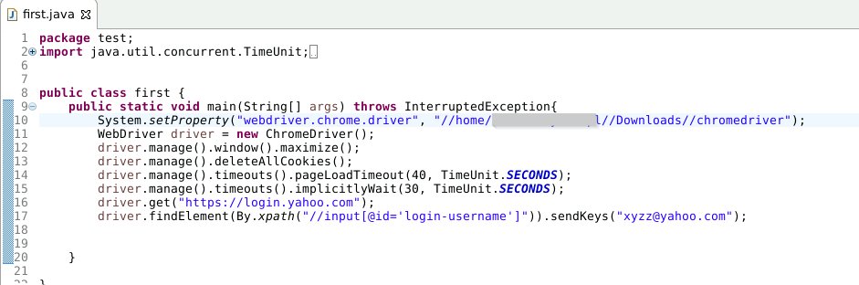

1.3 Right click on the written code and select **Run As** -> **Java Application**.

1.4 On executing the test case, you can see the output as shown below.

